Prairie Falcon Occupancy in Central California
RESEARCH ARTICLE

Peregrine Falcon re-establishment in central California reduces Prairie Falcon occupancy, but not per capita reproduction

ABSTRACT
Recolonization of raptors can lead to unpredictable impacts on other bird species in the community, especially in highly variable habitats undergoing climate change. Prior to dramatic population declines due to DDT, Peregrine (Falco peregrinus) and Prairie falcon (Falco mexicanus) ranges overlapped, resulting in competition for nesting sites. Here, we investigate the impacts of a recovering Peregrine Falcon population on a historically stable Prairie Falcon population in Pinnacles National Park. Using single- and multi-season occupancy models accounting for imperfect detection and long-term (2006–2021) monitoring data, we employed a causal inference framework to investigate the effects of Peregrine Falcon recolonization and environmental variables on Prairie Falcon occupancy and reproduction. Over the study period, the probability of Prairie Falcon occupancy decreased, but the conditional probability of successful reproduction was not affected by the increasing Peregrine Falcon occupancy. The probability of Prairie Falcon occupancy was higher in core areas (suitable falcon habitats with potential human climbing activities) and areas without Peregrine Falcon reproductive behavior. Contrary to occupancy, the conditional probability of successful reproduction was higher in non-core areas (suitable falcon habitats without climbing activities) and when there was less winter precipitation, indirectly supporting our hypothesis that reduced rainfall may result in less vegetation cover for prey and increased Prairie Falcon hunting success. Annual transitions in Prairie Falcon occupancy states were relatively low. The causal inference framework allowed us to eliminate several potentially confounding variables from consideration. However, our final models provided very similar inferences to the full model, primarily since these eliminated covariates had little association with the dependent variable (occupancy state). Our results showed that Prairie Falcon occupancy decreased without reproductive success being negatively affected, and were consistent with field observations that the overall falcon fecundity in the Park has remained stable. As Peregrine Falcon population grows and climate change-induced environmental variations intensifies, how the falcon species will interact with each other and with environmental variables requires continuing investigation. Future analysis can deepen understanding by employing two-species occupancy models along with additional covariate data including eyrie characteristics, prey population and predation data.
Keywords: Prairie Falcon, Peregrine Falcon, Occupancy, Disturbance, Pinnacles National Park,

RESUMEN
journal can provide a translation

LAY SUMMARY (150 words)
- Raptor recolonization can cause unpredictable impacts on the bird community, especially under climate change.
- An accurate understanding of raptors’ interaction with each other and with the environment is crucial for predicting their wellbeing and establishing conservation plans.
- We used single- and multi-season occupancy models with 15 years of monitoring data under a causal inference framework to study how a recovering Peregrine Falcon (Falco peregrinus) population impacted a historically stable Prairie Falcon (Falco mexicanus) population in Pinnacles National Park.
- Our results showed a decline in Prairie Falcon occupancy but not reproductive success during Peregrine falcon’s return; Prairie Falcon are more likely to occupy suitable habitats with potential human climbing activities, but reproduced more successfully without such activities and when it rained less in the previous winter.
- We encourage future research to deepen understanding by using two-species occupancy models and considering additional covariate data including eyrie characteristics, prey population and predation data.

INTRODUCTION
Over the past century, several bird species have been extirpated from North American ecosystems due to overexploitation, habitat loss, introduced predators, and pollutants such as DDT (Newton 2017). Conservation efforts have successfully helped some species to recolonize former ranges, especially when a single proximate cause of extirpation has been mitigated. For example, Brown Pelican (Pelicanus occidentalis) populations rapidly expanded into areas along the U.S. Pacific after reduction of DDT in the environment (Anderson et al. 2017). Similarly, California Condor (Gymnogyps californianus) populations were reintroduced in California after partial mitigation of poisonous lead in the environment extirpation in the wild and a successful captive breeding program (Seddon et al. 2007). In some cases, both bird extirpations and reintroductions may have measurable impacts on prey species (Ydenburg et al. 2004) or other species competing for similar resources or habitat. For instance, as formerly endangered Bald Eagles (Haliaeetus leucocephalus) expanded their range and role in Voyageurs National Park in Minnesota, top-down impacts from the eagles reversed the formerly successfully recovering populations of Osprey (via reduced nesting occupancy) and Great Blue Heronries (Cruz et al. 2019). Similarly, recovering Peregrine Falcon populations in British Columbia, Canada have caused Western Sandpipers to shorten their migration route stopovers, leading to reduced weight gain (Ydenberg et al. 2004). Thus, as predatory birds re-enter ecosystems, they may impact other species populations in both predictable and unpredictable ways.
Recovering species are also re-entering ecosystems that are undergoing both natural variability and long-term impacts of climate change (Thévenin et al. 2018, Gomides et al. 2021). Thus, both a recovering species and currently resident species may be experiencing different environmental, prey, and therefore competitive environments than they initially evolved in, altering competitive dynamics for nests, prey or other resources (Gomides et al. 2021).
Similar in size and physiology, the Prairie Falcon (Falco mexicanus) and the Peregrine Falcon (Falco peregrinus) have historically nested and foraged in close proximity in their extensive overlapping habitat range in North America, engaging in agonistic interactions while competing for cliff nesting sites (Anderson and Squire 1997, Dekker and Corrigan 2006). Peregrine Falcon are often the dominant aggressor in these interactions (Walton 1978, Dekker and Corrigan 2006, Emmons et al. 2011). When nesting sites for the two falcon species are contested or limited, one species may influence the abundance, nesting success, and distribution of the other by causing adult fatality, fledgling fatality, or egg abandonment (Dekker and Corrigan 2006). However, with the extirpation of Peregrine Falcon from much of their range during the 1960s - 2000s, many Prairie Falcon populations were temporarily released from this source of competition (Dekker and Corrigan 2006).
Prairie Falcon and Peregrine Falcon serve important ecosystem functions as top predators in Western North America and are considered important indicators of biodiversity and environmental health (McClure et al. 2018). However, their high trophic level and long generation time may make them especially sensitive to anthropogenic threats and environmental changes (McClure et al. 2018). Human disturbance such as off-road vehicle use, climbing, and hiking can lead to nest failures and territorial abandonment of falcons and other raptors (Porter and White 1973, DeLong and Steenhof 2004). In the Mojave desert (California), human disturbance is negatively correlated with Prairie Falcon productivity, and successful nests are often in locations less accessible by humans than those of failed nests (Boyce 1988, cited by DeLong and Steenhof 2004). Similarly, in the European Alps, where both Peregrine Falcon and Golden Eagle (Aquila chrysaetos) reside, climbers’ activities have led to offspring mortality due to forced nest abandonment or premature flight attempts by nestlings (Giuliano 1994).
Both long- and short-term changes in precipitation and temperature regimes due to climate change or natural variation may also negatively impact falcon life history and population dynamics (Monadjem et al. 2013, Frank 2017, Emmons 2023). Steenhog et al. (1997, 1999) and Emmons (2023) suggested that higher pre-breeding season precipitation is associated with greater vegetation growth, i.e., greater vegetation cover, which may block Prairie Falcon’s view of small ground mammals and subsequently hinder foraging success. Increased precipitation during a breeding season has been shown to decrease hatching success and nestling survival rate through direct exposure, reduced prey activity, reduced foraging efficiency, and amplified lethal effects of ectoparasites on falcon young (Olsen and Olsen 1989, Bradley et al. 1997, Steenholf et al. 1999, Anctil et al. 2014, Fisher et al. 2015). Additionally, severe winter weather before a breeding season led to a lower likelihood of laying eggs due to reduced mass in kestrels and Golden Eagles (Steenhof et al. 1997). Beecham & Kochert (1975, cited by Steenhof et al. 1997) identified heat stress as a significant mortality factor for eagle nestlings in Idaho. Moreover, Olsen and Olsen (1989) found that cold temperatures lower hatching success and nestling survival rate in falcons.
Pinnacles National Park (“Pinnacles”) in Central California has extensive rugged cliffs that provide many suitable Prairie Falcon (and, when present, Peregrine Falcon) nesting sites. While raptor populations are often difficult to monitor due to low population densities and rough landscapes (Newton 2010), Prairie Falcon’s relatively high density at Pinnacles facilitates tracking of trends in occupancy and reproduction (Emmons 2023). Within this relatively high Prairie Falcon nesting density, Peregrine Falcon returned to the park in 2004 for the first time in 49 years after their extirpation related to chemical insecticide (Dichlorodiphenyltrichloroethane - “DDT”) in the environment that bioaccumulates through the food chain and depressed reproductive success via eggshell thinning (Emmons 2023). By 2020, four known Peregrine Falcon pairs were nesting in Pinnacles.
Pinnacles’ unique landscape also attracts a large number of hikers and rock climbers. Several climbing routes at Pinnacles are in close proximity to falcon nesting sites, which can have potential impacts on falcon occupancy and reproduction (Giuliano 1994, Richardson and Miller 1997, Camp and Knight 1998, Emmons 2023). In an effort to balance human recreational activities with raptor nesting, Pinnacles instituted a Falcon Monitoring Program in 1987 and uses this information to establish climbing and hiking advisories in areas with active nesting activities (Emmons 2023).
As the park transitions back into a two-falcon species ecosystem under changing climatic conditions that could shift habitat and resource availability, obtaining accurate information on falcon occupancy and reproduction becomes crucial, as it is essential for evaluating the impact of human disturbance, guiding effective management decisions, and assessing progress in conservation management efforts.
Previous Prairie Falcon occupancy and reproduction studies were generally in regions with colder (often below freezing) winter temperatures, not analyzed in an occupancy model framework, and did not spatially and temporally overlap with recolonization of Peregrine Falcons. Here, we employed occupancy modeling using long-term Prairie Falcon occupancy data from Pinnacles National Park, California, USA during a period of Peregrine Falcon recolonization to: 1) estimate trends in annual and site-specific level of occupancy and successful reproduction, 2) use causal analysis to understand the effects of Peregrine Falcon recolonization and environmental variables on Prairie Falcon occupancy and reproductive success, 3) estimate detection probabilities for Prairie Falcon occupancy and reproduction, 4) estimate occupancy (unoccupied, occupied, and breeding) state transition probabilities, and 5) provide methodological and analytical recommendations to improve the utility of this long-term monitoring program.

METHODS

Study Area
Pinnacles National Park (10,694 ha) is located in the Gabilan Mountains of the central Coast Range of California, with elevation ranging from 244 to 1,007 meters (Figure 1). The climate is Mediterranean with hot, dry summers and cool, damp winters. Temperatures range from a seasonal mean of 5.2 ̊C in winter to 25.2 ̊C in summer and average annual rainfall is 42.3 cm, with the majority of precipitation occurring from November to April. Pinnacles provides a diverse range of habitat types including volcanic rock formations and outcroppings, California mixed chaparral, pine-oak woodlands, grasslands, and riparian creek corridors (Emmons 2023).
Suitable habitats for Prairie Falcon cliff-nesting in Pinnacles are divided into two management categories. Core areas are where recreational climbing impacts may occur, since they contain climbing routes accessible to park visitors. Non-core areas refer to all other suitable habitats (Emmons 2023). Each Prairie Falcon territory may contain multiple suitable nesting sites, however, each territory only hosts one breeding falcon pair (i.e., one nest) in a given season. Thus, we use the terms “site” and “territory” interchangeably.

Field Surveys and Data
We collected Prairie Falcon occupancy and reproduction data at Pinnacles using standardized methods from the National Park Service’s Inventory and Monitoring Program (Emmons et al. 2011).
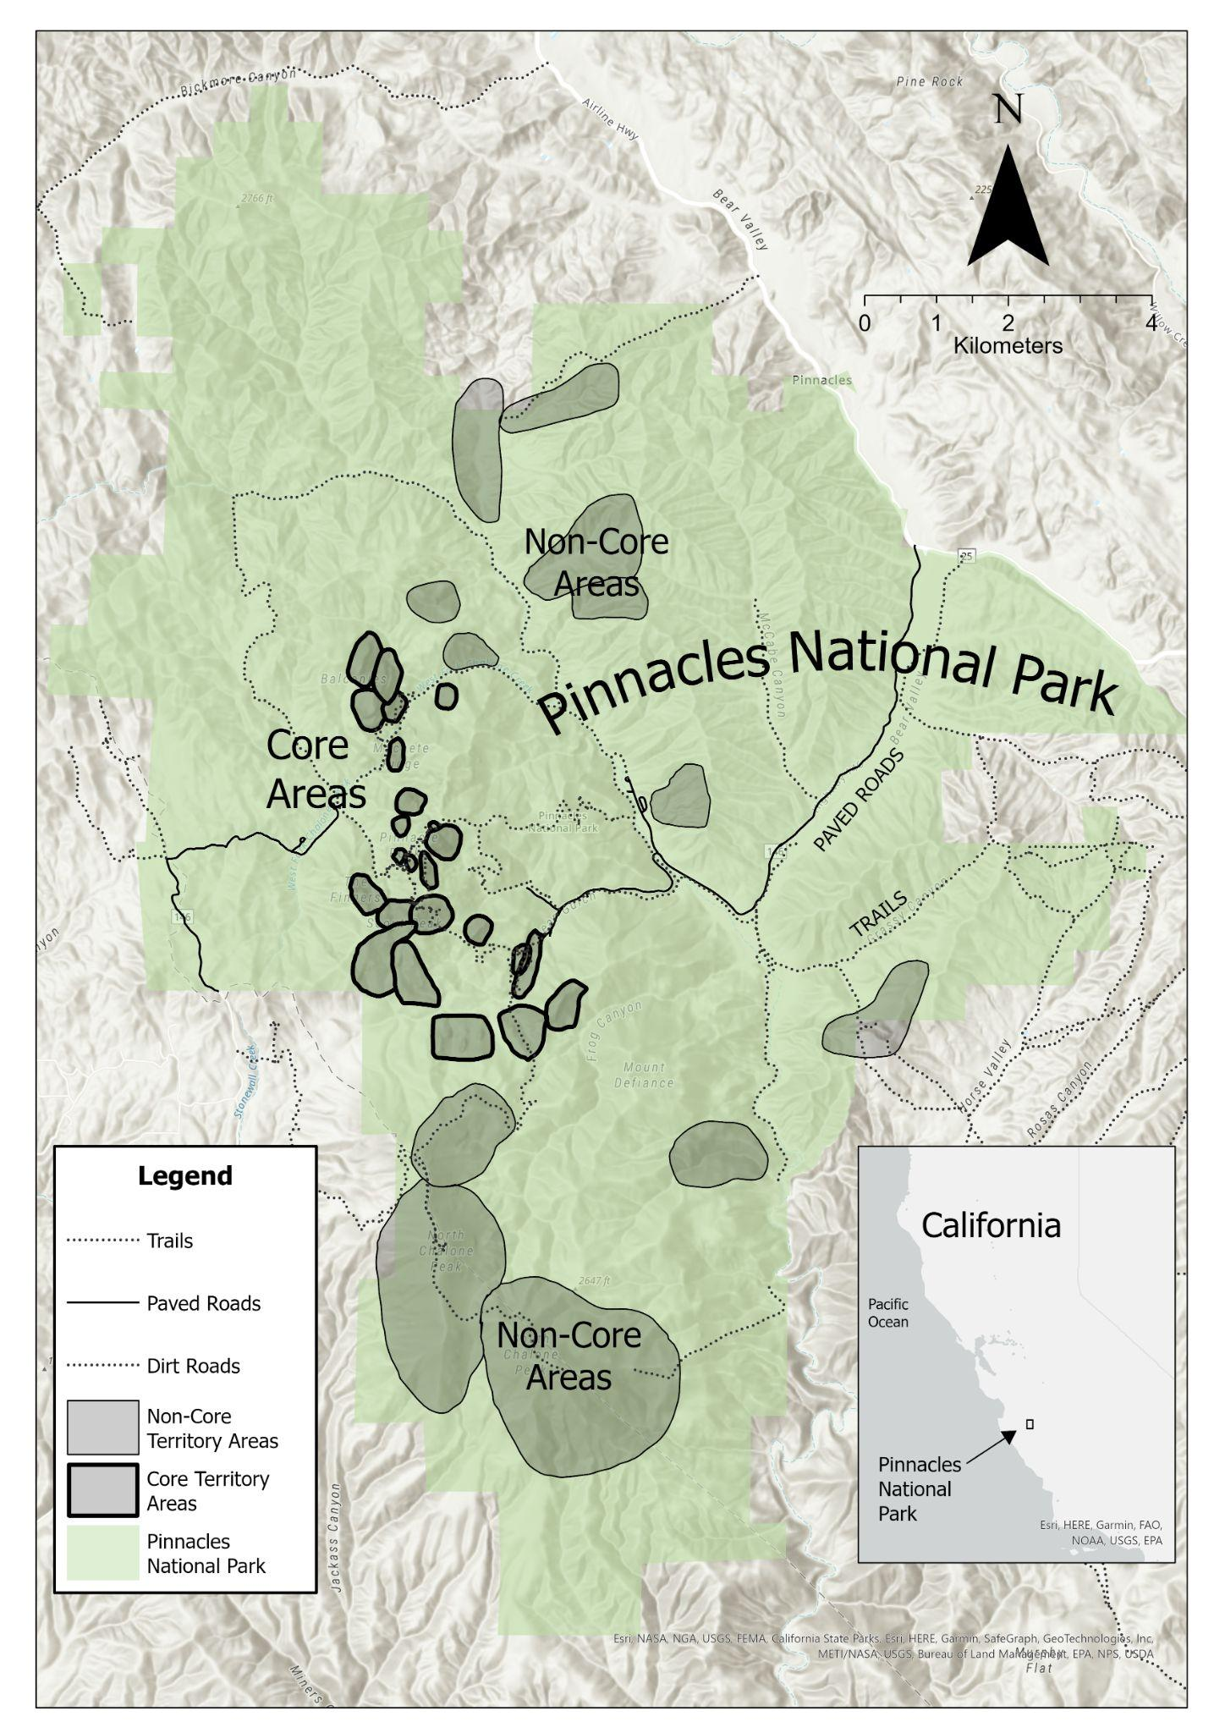
Figure 1. Prairie Falcon core and non-core nesting areas at Pinnacles National Park, California, USA. Core areas have higher use by recreational mountain climbers and are denoted with darker polygon outlines than non-core areas.
Starting in early January or late December of the previous calendar year, each potential nesting site was surveyed at least 3 times for 4 hours each (12 hours total) at the beginning of the breeding season. Each of these initial surveys was spaced between 21 to 28 days apart to account for potential changes in nest status early in the season and improved probability of detection. During a survey, the cliff nest was observed from the locations that provided the best view with spotting scopes and binoculars. Field data were recorded on standardized datasheets and field notebooks and later entered into a Microsoft Access Relational database. Nests determined to be active (i.e., territorial occupancy, courtship, or incubation of eggs) during the initial 3 surveys were revisited periodically and assessed for occupancy through July of each year to confirm rearing of nestlings and fledging of young (Emmons 2023). The number and frequency of revisits are dependent on the visibility of eggs and nestling during each survey, though a nest is usually revisited at least 2-3 times to estimate the age of nestlings in order to accurately anticipate and confirm fledging of all youngs (G. Emmons, personal communication). To assist with park management objectives, nests in core (climbing) areas were monitored more frequently than those in non-core areas and during weekend days when climbers were more likely to be present (Emmons 2023).
Occupancy and productivity surveys were conducted during December 2006 - July 2021. All known potential territories in the park were surveyed annually. We defined the “Breeding Year” variable (Yr) which begins on December 1st of the previous calendar year to account for the earliest surveys in a breeding season. Occasional surveys during August, September and October were excluded from occupancy analysis since the breeding season generally ends by late July. We also excluded 3 of the 49 sites from analysis since they only had one survey each during the entire study period. Environmental data, including maximum and minimum temperature, drought indices, and daily precipitation were accessed through Climate Engine (Huntington et al. 2017) by selecting a rectangular polygon enclosing the area of Pinnacles and specifying the time period as described in Table 1.

Occupancy State Classification
For each site $×$ year combination, we compiled a detection history by classifying each observed nest status into one of three states: 0 = unoccupied, 1 = occupied without successful reproduction, or 2 = occupied with successful reproduction. Successful reproduction was defined as confirmed fledging with young seen perched and/or flying away from the nest site (Emmons 2011). To arrive at this final state classification, we followed a two-step process. In step one, sites were each given an initial label based on the visit status. Specifically, sites with no territorial or incubating adults, eggs, nestlings, or fledglings were labeled as 0; Sites with territorial adults only (i.e., no incubating behavior, eggs, nestlings or fledglings) were labeled as 1; Sites where incubating behavior, eggs, or nestlings were observed but have no fledgling were labeled as 1.5, regardless of adult presence; and sites with fledglings observed were labeled as 2, regardless of presence of other stages. In the second step, the states of sites with an initial label of 0, 1, or 2 remained unchanged, while the state of each site with an initial 1.5 was updated based on the site's highest state value in a given season. If a site had a highest state of 2 in the season, the initial 1.5 would be updated to a 2. Otherwise, its initial 1.5 would be updated to a 1. This process resulted in a series of 0s, 1s, and 2s analyzed as the detection history.

Table 1. Summary of covariates predicted to influence Prairie Falcon 𝜓 and r in multi-state occupancy models.

Variable (Abbreviation) | Unit | Mean | Range | Relevance to 𝜓 | Relevance to r
Breeding Year (Yr) | year | N/A | 1 - 15 | Probability of occupancy can change over time | Conditional probability of successful reproduction can change over time
Area Type (A) | factor | N/A | {0,1} | Core area may have lower probability of occupancy due to human disturbance | Core area may have lower conditional probability of successful reproduction due to human disturbance
Annual Visitors (V) | count | 224473 | 161019 - 393219 | More visitors = greater human disturbance | More visitors = greater human disturbance
Peregrine Falcon occupancy (PEFA) | factor | N/A | {0,1,2} | PEFA compete with Prairie Falcon for nesting sites | Agonistic interactions could impact nest success
Winter severity  (December - February) (WS) | HDD | 1453.2 | 1101.5 - 1844.8 | N/A | Colder winter = lower body mass = lower likelihood to lay eggs (Steenhof et al. 1997)
Extreme heat during breeding (April 15 - June 15) (H) | count | 8.3 | 1 - 16 | N/A | Extreme heat = higher nestling mortality (Beecham & Kochert 1975)
Extreme cold during breeding (March 15 - May 7) (C) | count | 10.1 | 0 - 31 | N/A | Low temperature = lower hatching success and nestling survival rate (Olsen and Olsen 1989)
Winter total precipitation  (December - February) (WP) | mm | 197.6 | 60.2 - 347.0 | Higher precipitation = more vegetation growth blocking falcon’s view on prey = lower foraging success = lower occupancy (Steenhof et al. 1999) | Higher precipitation = more vegetation growth blocking falcon’s view on prey = lower foraging success = lower reproductive success (Steenhof et al. 1999)
Winter Average Short-Term Drought (December - February) (SD) | index | -0.3 | -1.9 - 0.5 | Same as winter precipitation | Same as winter precipitation
Annual Average Long-Term Drought (LD) | index) | -0.6 | -1.9 - 0.4 | Same as winter precipitation | Same as winter precipitation
Heavy Precipitation during breeding  (March 15 - June 15) (P) | Days | 8.3 | 1 - 18 | N/A | More rain = direct exposure, reduced prey activity, reduced foraging efficiency, and amplifying the lethal effects of ectoparasites

Since a nest is considered successful when fledging is confirmed, no further visits to this nest site are required by the protocol (Emmons et al. 2011, Emmons 2023). In order to make the data consistent with the monitoring protocol, we excluded any surveys after the first observation of fledglings for each site $×$ year combination from our analysis.
Peregrine Falcon data for each site $×$ year combination were also classified into three states. Since we were only concerned with whether Peregrine Falcon were present and reproductive at a site (as opposed to whether the young fledged), each Peregrine Falcon observation was labeled as 2 if Peregrine Falcon fledglings, nestlings or eggs were observed, labeled as 1 if only adults with territorial behavior were observed, and labeled as 0 otherwise. The maximum state for each territory in a year was used as the Peregrine Falcon covariate value to evaluate the potential effects of Peregrine Falcon on Prairie Falcon.
Two types of observation errors can be made during occupancy surveys: when we failed to detect a species at an occupied site, or when we assigned the wrong occupied state to a site (e.g., not seeing hatchlings and recording state 2). Both types of errors are estimated by multi-state models and we assumed there were no false positives (i.e, recording a true state 1 as a state 2 or a state 0 as state 1 or 2) (MacKenzie et al. 2009).

Single-Species, Multi-State Occupancy Modeling
We followed the multi-state framework described in Kéry and Royle (2022, p. 345 – 386) to estimate model parameters (Table 1, Figure 2). Single season occupancy models were used to estimate temporal and covariate effects, while multi-season models were used to estimate annual transition rates between states.
In the single-season models, we considered each sampled site $×$ year combination to be a distinct site because we were interested in the trends over time of occupancy and reproductive success rather than the turnover rates. In the multi-season models, we considered each nesting site to be a distinct site with multiple seasons (i.e., years) of surveys to estimate transition probabilities.

Single-season occupancy model. The static occupancy model estimates the distribution of sites across three predefined states. The model is composed of two groups of parameters: a state vector 𝛀 and an observation matrix 𝚯. The state vector has three elements representing the probability that a site is in state 0, 1, and 2, respectively. The model takes the form:

𝛀_{i} = [1 - 𝜓 𝜓(1 - r) 𝜓r]_{i}

where 𝜓 is the probability of occupancy of site i, and r is the conditional probability that an occupied site also has successful reproduction.
The observation matrix describes how likely each true state at site i is to be in a certain observed state in survey j, with rows representing the true states and columns representing the observed states. It takes the form:
$$Θ_{i,j,t}\text{ = }{\left[\begin{matrix}1 & 0 & 0 \\ 1-p_{1} & p_{1} & 0 \\ 1-p_{2} & p_{2}(1-δ) & p_{2}(δ)\end{matrix}\right]}_{i,j,t}$$
where p1 represents the probability of detection given the true state is 1, p2 represents the probability of detection given the true state is 2, and 𝛿 represents the probability of successfully observing state 2, given that the species has been detected. All single-season models used a conditional binomial parameterization (Nichols et al. 2007).

Multi-season occupancy model. The dynamic multi-state model estimates the probabilities of state transitions between seasons. It estimates a transition probability matrix 𝚽 in addition to an initial state vector 𝛀 and an observation matrix 𝚯. The transition probability matrix has three rows and three columns, with the rows representing the state at year t and the columns representing the state at year t+1. It takes the form:
$$Φ_{i,j,t}\text{ = }{\left[\begin{matrix}p_{00} & p_{01} & p_{02} \\ p_{10} & p_{11} & p_{12} \\ p_{20} & p_{21} & p_{22}\end{matrix}\right]}_{i,j,t}$$
where p_{xy} represents the probability that a site in state x in year t is in state y in year t+1.
The multi-season model used a multinomial parameterization (Kéry and Royle 2020).

Covariate Selection

State covariates. Breeding year, visitor number (V), Peregrine Falcon, and precipitation before breeding season were considered for 𝜓 (probability of occupancy). To quantify precipitation before breeding season, we considered three potentially correlated measurements: a) total winter (December - February) precipitation (WP), b) average winter (December - February) Short-Term Drought Indicator Blend (SD), and c) annual average Long-Term Drought Indicator Blend (LD). The two drought indicators blend approximate drought-related impacts on time scales ranging from a few days to a few months and a few months to a few years, respectively, to account for potential lag in the effects (“Product Description”). We hypothesized 𝜓 to be decreasing over time, lower in core areas, with more visitors, when peregrine falcons are present, and when there was greater precipitation in the previous winter.
The above-mentioned variables were also considered for r (conditional probability of successful reproduction). We additionally included precipitation during breeding season (P), winter severity preceding the breeding season (WS), and severe heat (H) and cold (C) during breeding. Precipitation during breeding was measured with the number of days with “heavy rain” (>8 mm/day) from March 15th to June 15th every year (Anctil et al. 2014). We quantified winter severity with Heating Degree Days (HDD), calculated as the sum of the difference between daily mean temperature and 18°C during December to February (Steenholf et al. 1997). We calculated heat stress during breeding as the number of days that the daily maximum temperature exceeded 32 °C in the nestling period (April 15 - June 15), and cold temperature during breeding was measured with the number of days when the daily minimum temperature was below 1.67 °C during and 3 weeks after the incubation period (March 15 - May 7) when the young were the most vulnerable to cold weather (Anctil et al. 2014). We hypothesized that r would be decreasing over time, the shared covariates would have the same effects on r, and winter severity, along with both severe heat and cold during breeding, would negatively impact r. Prior to occupancy modeling, all continuous covariates (except breeding year) were standardized with mean = 0 and sd = 1.
In addition, to comply with the model’s assumption that there is no spatial correlation between the state of sites, we implemented the “Area Type” site covariate (A) for occupancy, reproduction and detection probabilities to account for potential spatial correlations between sites (MacKenzie et al. 2009). We assigned an area type covariate value of 1 to surveys in core areas and a value of 0 to surveys in non-core areas. We hypothesized that 𝜓, r and detection probabilities (p¹, p² and 𝛿) would be lower in core areas as a result of more visitor interference than in non-core areas.
Detection covariates. We considered two detection covariates to satisfy the “closure assumption” of no state transitions within a season. First, we defined a binary “Nestling Period” detection covariate for the conditional detection probabilities (p2 and 𝛿). Since it is impossible to detect successful reproduction early in the breeding season before eggs or hatchlings are present, the probability of correctly classifying a site as reproductively successful (state 2) varies during the breeding season (Mackenzie et al. 2017). To account for this, we calculated a cut off threshold as the average earliest day on which an egg or nestling (i.e., an initial state 1.5) was observed across all site $×$ year combinations. This value was used as the proxy to the earliest day in a season on which obvious signs of successful reproduction were likely to be observed. The “Nestling Period” detection covariate has a value of 1 if the survey was made after the threshold and 0 otherwise. We hypothesized that detection probabilities would be higher after the cutoff and that the 𝛿 value would be close to zero before the cutoff.
Second, we defined a binary “Initial Surveys” detection covariate for the detection probability (p1). Three initial surveys were conducted early in the season at each site to determine whether the site was active. In the case that a breeding pair had not occupied a site during the first one or two of the initial surveys but arrived after, the closure assumption may be violated. For example, if the birds didn’t occupy a site, and therefore were not detected until the third survey, detection history would show 001, leading the model to interpret the first two observations as failed detections while in the field there was no misclassification. To account for this, we calculated a cutoff threshold as the mean date of first state 1 detection across all years and sites. This cutoff value was a proxy to the average earliest day in a year on which Prairie Falcon occupied a nest over the study period. The “Initial Surveys” detection covariate had a value of 1 if a survey was made before the threshold and a value of 0 if on or after. We predicted that p1 would be low before the cutoff and higher after the cutoff.

Causal Inference Model Building and Selection
We built a series of single-season models based on the causal inference framework described by McElreath (2020) embedded within the Occupancy model selection frameworks recommended by both MacKenzie et al. (2017) and Kéry and Royle (2020). Importantly, MacKenzie et al. (2017) generally recommend a stepwise approach to building occupancy models with detection and state covariates modeled in sequential order and this practice has been commonly used in multi-state occupancy modes over the past decade. Conversely, Kéry and Royle (2020) generally recommend estimating both detection and state parameters concurrently in a single full model containing all hypothesized covariates. We approached occupancy modeling using the stepwise approach (detection and state covariates were done sequentially), but selected state covariates via a full model approach (no model selection) with causal inference procedures when covariates were potentially confounded (McElreath 2020). To illustrate these state covariates and confounds, we created two separate directed acyclic graphs (DAGs) (one for each state parameter, 𝜓 and r) to illustrate hypothesized relationships both among covariates and between covariates and state parameters (Figure 2). Covariates hypothesized to be independent from all other covariates were included in all models, while for each group of potentially dependent covariates, conditional independence was examined (i.e., we checked if each covariate provides additional information – i.e., a change in parameter estimates – about the parameter given another covariate in the causal link to this parameter) (McElreath 2020). If a covariate was independent of the parameter given another covariate with significant coefficient, it would be omitted in the final model. If none of the covariates in a group had a significant coefficient, a single arbitrary covariate in the group was included in the final model to avoid overfitting, confounding, or correlated covariates. Generally, this process should not greatly affect inferences of covariates that were hypothesized to directly affect occupancy and reproduction (e.g., Peregrine Falcon, Year, visitors, etc.). However, by sequentially adding covariates with interacting effects, such as precipitation and drought, we sought to discover which had the greatest measurable effect on Prairie Falcon state. During this process, detection
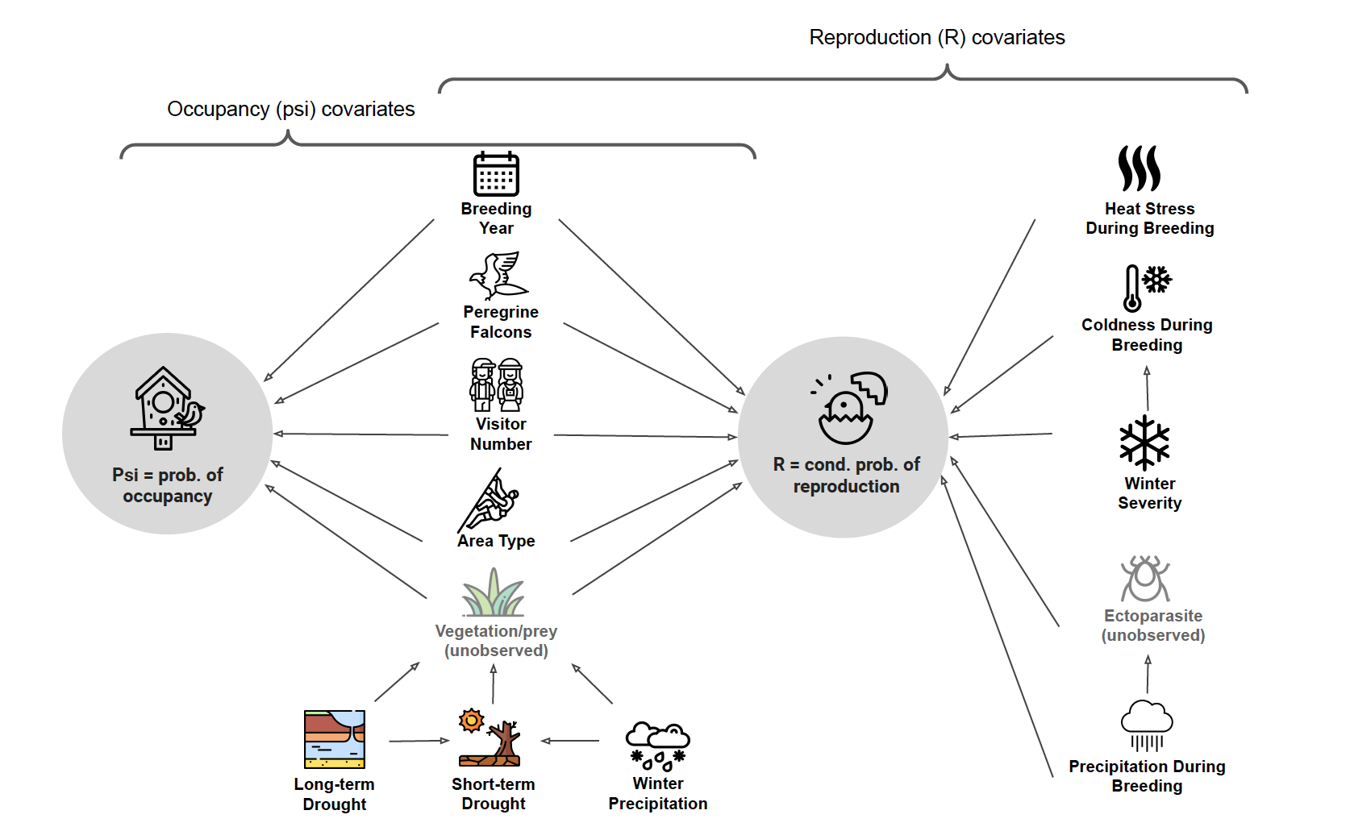

Figure 2: Directed Acyclic Graph (DAG) of hypothesized effects of environmental and biological covariates on Prairie Falcon Occupancy (psi) and reproduction (R). All of the psi covariates also potentially affect R, with R having several additional hypothesized covariates. Gray icons represent unobserved data that may be affected by observed data. For example, long-term drought should affect vegetation density (unobserved = no data) and ability to find prey which may affect Psi and/or R.

covariates were held constant for all candidate models and were set based on a priori assumptions (see below).
Once the best model for state parameters was selected, we held the state covariates constant and repeated the model selection procedure to determine the best setting for detection covariates. In order to estimate the averaged transition probabilities independent of covariate effects, we did not consider environmental covariates in the multi-season models except for the detection covariates.
For the “Initial Surveys” detection covariate, to examine any effects of variability of the date of first survey at each site, we ran the final model with multiple cutoff values spaced one week apart counting back from 50 days after December 15th (the original calculated cutoff) to 8 days after December 15th (Table S3, Figure S1).
We used a nonparametric bootstrap of the final model under multinomial parameterization to check for overdispersion (ĉ) in the dataset using the sum of squared error, X² and Freeman-Tukey comparisons of observed and expected data. We checked the final model for overfitting by ensuring that the rank of the Hessian matrix was ≥ the number of parameters in the model. Occupancy analyses were performed in R 4.2 (R Core Team 2020) using the occuMS function in the unmarked package (Fiske and Chandler 2011).

RESULTS

Single-Season Models
We fitted 27 single-season causal models based on the DAGs (Table S1). After eliminating covariates that were not causally linked to the state parameter, the final model included breeding year, peregrine falcon, area type, annual visitors, and winter precipitation as covariates for 𝜓; peregrine falcon, area type, annual visitors, winter precipitation, precipitation during breeding, winter severity, and extreme high temperature during breeding for r; area type for p¹; no covariate for p², and “nestling period” detection covariate for 𝛿. ĉ (overdispersion) was estimated at 1.0, 2.6, and 0.61 when calculated using sum of squared error, X², and Freeman-Tukey, respectively, suggesting that overdispersion was not an important problem for model interpretation. The Hessian rank minus the number of parameters was zero, indicating that the final model was not overfit.
Full Model vs. Causal Model Inferences. There were negligible differences in the importance of covariates between the full and final causal model. Nonetheless, the causal analysis allowed us to eliminate three covariates. Short drought and long drought were causally less informative than simple winter rainfall, and number of cold days was less informative than winter intensity (HDD: Figure 2, Table S2).

Probability of Occupancy. Breeding year and area type were the only statistically significant (p < 0.01) covariates for the probability of occupancy 𝜓. 𝜓 decreased over time and was higher in core areas (Table 2, Figure 1a). Peregrine Falcon State 2 also showed a negative impact on 𝜓 (p = 0.06), meaning that observed reproductive behavior of Peregrine Falcon was associated with a lower probability of Prairie Falcon occupying the site.

Conditional Probabilities of Successful Reproduction. Area type and winter precipitation were the only important (p < 0.05) covariates for the conditional probability of successful reproduction r. Contrary to 𝜓, r fluctuated over time and was higher in non-core areas. r decreased as winter precipitation increased (Table 2, Figure 1b&d).

Table 2. Estimated covariate effects on state parameters under the final causal model (𝜓 = Yr + PEFA + A*V + WP, r =PEFA + A*V + WP + P + WS + H, p1 = A, p2 = None, 𝛿 = Nestling Period). P values < 0.10 are in bold.

 |  | 𝜓 |  |  |  | r
Covariate |  | Estimate | SE | p< |  | Estimate | SE | p<
(Intercept) |  | 0.46 | 0.19 | 0.02 |  | -0.62 | 0.17 | 0.01
Breeding Year |  | -0.06 | 0.02 | 0.01 |  | N/A | N/A | N/A
PEFA State 1 |  | -0.26 | 0.35 | 0.46 |  | 0.04 | 0.58 | 0.94
PEFA State 2 |  | -0.86 | 0.46 | 0.06 |  | -0.52 | 0.90 | 0.56
Non-Core Area |  | -0.44 | 0.18 | 0.01 |  | 0.57 | 0.29 | 0.05
Annual Visitors |  | -0.01 | 0.10 | 0.93 |  | 0.14 | 0.17 | 0.44
Winter Precipitation |  | -0.01 | 0.08 | 0.93 |  | -0.43 | 0.17 | 0.01
Heavy Precipitation during Breeding |  | N/A | N/A | N/A |  | 0.02 | 0.16 | 0.88
Winter Severity |  | N/A | N/A | N/A |  | 0.22 | 0.15 | 0.15
Extreme Heat during Breeding |  | N/A | N/A | N/A |  | -0.06 | 0.16 | 0.70

Detection Probabilities. Area type was statistically significant for p1 (probability of detection) (p < 0.00). p1 was lower in core areas than in non-core areas. “Nestling period” detection covariate was significant for 𝛿 (probability of successfully observing state 2, given detected) (p < 0.02). 𝛿 was notably higher later in the season when nestlings and eggs were more likely to be present (Tables 2 & 5).

We did not include the “nestling period” detection covariate for p2 in the final model due to its high standard error (Est. = 15.5, SE = 229.8, p < 0.9). Excluding this covariate didn’t affect the estimates of detection probabilities. During the model selection process, area type was not statistically significant for either p2 or 𝛿. In order to achieve the simplest final model, we exclude area type as a covariate for p2 and 𝛿.
Varying the cutoff date of initial surveys had little impact on p1 estimates for non-core areas (Table S3, Figure S1). Including the “Initial Surveys” detection covariate also had no large impact on the estimated values of p1 and estimated coefficients for other covariates compared to when it was not considered. To achieve the simplest final model, we excluded “Initial Surveys” detection covariate for p1.

Interannual State Transitions from Multi-Season Models
Similar patterns were observed for all three states (Figure 3). All states were most likely to stay unchanged in the subsequent year, with state 0 showing the highest probability (0.88) of stasis (i.e., unoccupied sites were 88% likely to remain unoccupied in the subsequent year, Table 4). Additionally, it was very unlikely for a site to transition across two states (i.e., changing from state 0 to state 2 (probability = 2%, CI: 1% - 6%) and vice versa (probability = 3%, CI: 1% - 11%)). The likelihood of moving from state 1 (occupied without reproduction) to state 2 (occupied with successful reproduction) was 19% (CI: 15% - 25%), while moving from state 2 to state 1 was 37% (CI: 26% - 46%).

Table 3. Estimated covariate effects on detection parameters (p1, p2, and 𝛿) under the final model (𝜓 = Yr + PEFA + A*V + WP, r =PEFA + A*V + WP + P + WS + H, p1 = A, p2 = None, 𝛿 = Nestling Period). P values < 0.10 are in bold.
 |  | p1 |  |  |  | p2 |  |  |  | 𝛿
Covariate |  | Est. | SE | p< |  | Est. | SE | p< |  | Est. | SE | p<
(Intercept) |  | -0.07 | 0.08 | 0.39 |  | 2.24 | 0.11 | 0.01 |  | -1.69 | 0.13 | 0.01
Area Type 0 |  | 0.54 | 0.17 | 0.01
Nestling Period 1 |  |  |  |  |  |  |  |  |  | 3.87 | 0.20 | 0.01

Table 4. Transition Probability Matrix of mean (95% CI) change in Prairie Falcon occupancy state from year t to year t+1 average over the entire study period. The diagonal values are derived from values on the same row and therefore do not have CIs.
 | Year_{t + 1}
Year_{t} |  |  | 0 | 1 | 2
Year_{t} | 0 |  | 0.88 | 0.10 (0.06 - 0.13) | 0.02 (0.01 - 0.06)
Year_{t} | 1 |  | 0.27 (0.20 - 0.35) | 0.54 | 0.19 (0.15 - 0.25)
Year_{t} | 2 |  | 0.03 (0.01 - 0.11) | 0.37 (0.26 - 0.46) | 0.60

Estimated Number of Occupied and Reproductive Sites over the Study Period
We multiplied the total number of potential sites in our dataset by estimated 𝜓 and 𝜓*r to approximate the number of occupied sites and reproductive sites in our study area (Figure 3(e) (f)). ~24 out of 43 sites were occupied by Prairie Falcon in 2007 and the number gradually decreased to ~15 occupied sites in 2021. The estimated number of successfully reproductive Prairie Falcon territories fluctuated over time between 4 sites and 13 sites. The mean number of Prairie Falcon fledglings per nest was steady over the study period, with no change during the recolonization of territorial Peregrine Falcon (Figure 4).

Table 5. Estimated Prairie Falcon Detection Probabilities for p1, p2, and δ over the study period.

Parameter | Estimate | 95% CI
p¹_{core} | 0.48 | 0.44 - 0.52
p¹_{non-core} | 0.62 | 0.55 - 0.68
p² | 0.90 | 0.88 - 0.92
δ_{early} | 0.16 | 0.13 - 0.19
δ_{late} | 0.90 | 0.87 - 0.92

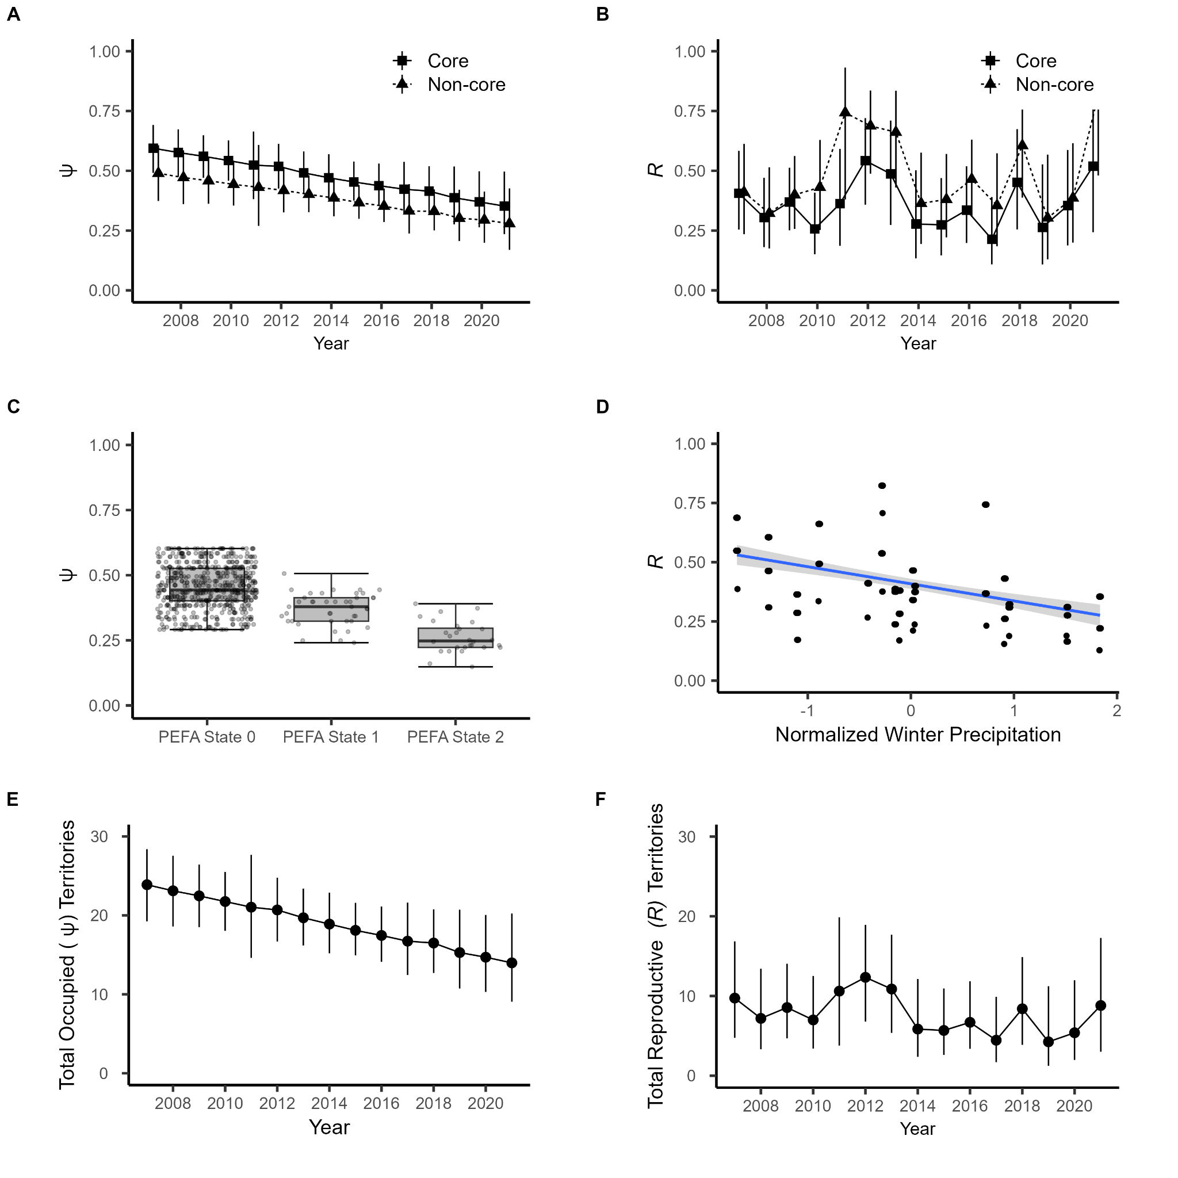

Figure 3. Final causal model estimates for covariate effects on Prairie Falcon reproduction (R) and occupancy (𝜓) from 2007-2021. (A) Yearly average estimated Prairie Falcon 𝜓 by area type, with mean 95% CI; (B) Yearly average estimated R by area type with mean 95% CI; (C) Relationship between 𝜓 and Peregrine Falcon; (D) Relationship between r and winter precipitation; (E) estimated number of occupied; and (F) reproductively successful territories at Pinnacles National Park 2007 - 2021.

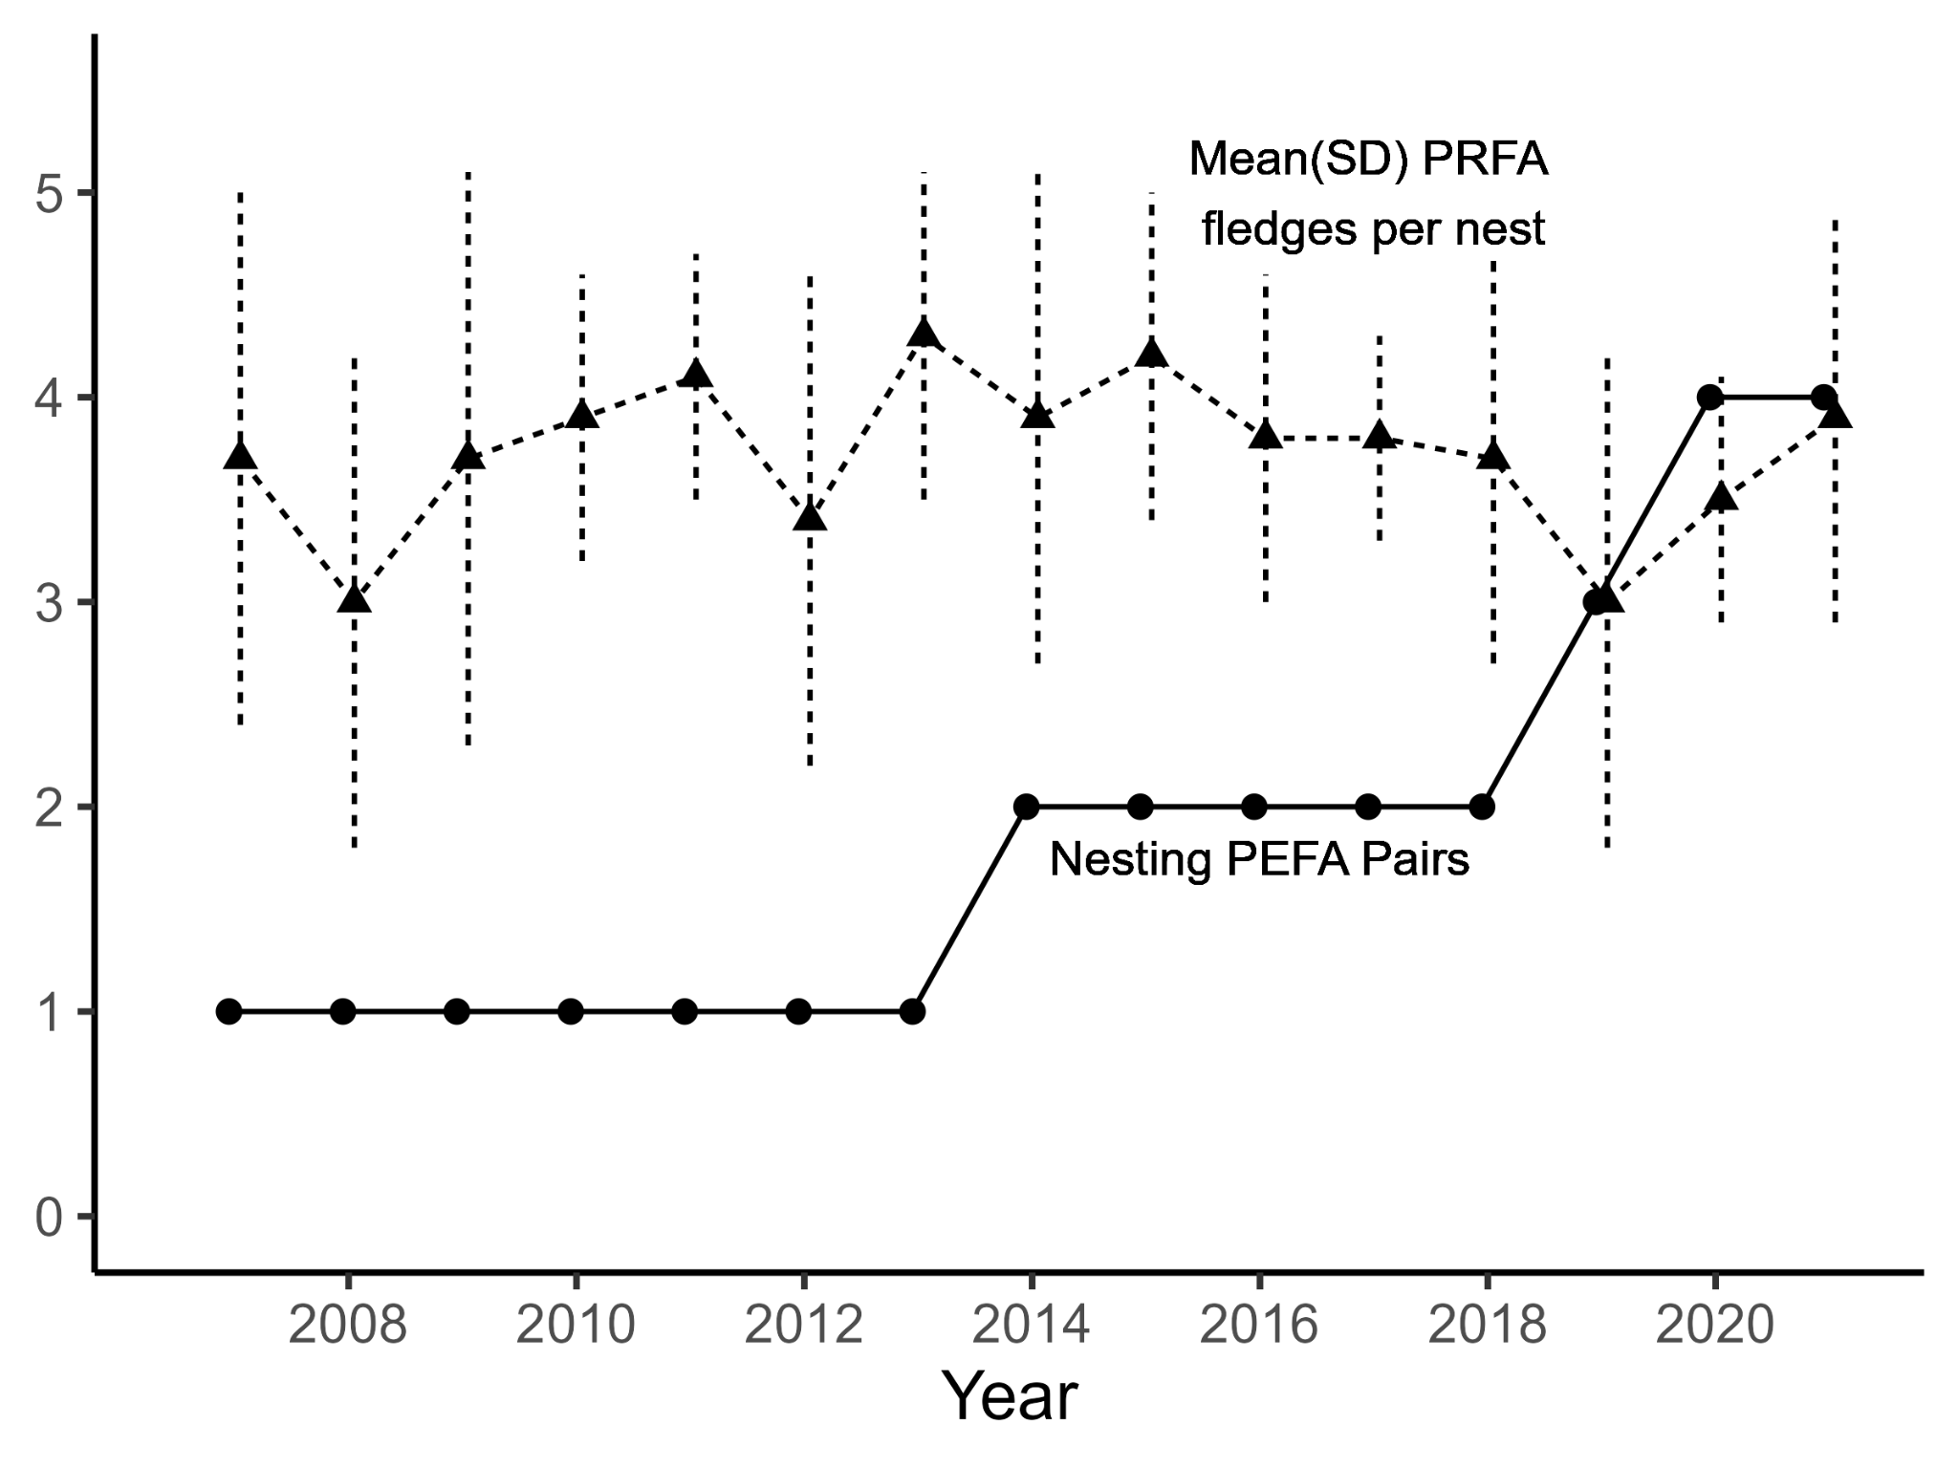

Figure 4. Mean and standard deviation of Prairie Falcon fledges per nest and number of territorial/nesting Peregrine falcons in the study area from 2007 - 2021.

DISCUSSION
Reintroduction and recovery of species in ecosystems and food webs may have unpredictable effects, especially given natural variability in ecosystems over time and space (Gomides et al. 2021). As Peregrine Falcon recolonize Pinnacles National Park, they are directly displacing Prairie Falcon from nesting sites, resulting in a lower overall Prairie Falcon occupancy and reproduction. However, Prairie Falcon productivity at individual nest sites remained stable over the study period, meaning that once nests have been secured by Prairie Falcon, there are not yet additional impacts on per capita fledge production. As the Peregrine Falcon population continues to recover, it is likely that some level of equilibrium between Prairie Falcon and Peregrine Falcon will be realized, as these species regularly co-existed prior to Peregrine Falcon extirpations (Anderson and Squire 1997).
As climate change affects the Pinnacles National Park environment, the dynamics between the falcons could shift. While Prairie Falcon occupancy and reproduction were generally resilient to most environmental variation over the study period (except for annual rainfall), this variation can be expected to become more pronounced under climate change impacts on the region (Vázquez 2017).

Prairie Falcon Occupancy and Reproduction
Trends. While we found a negative trend in Prairie Falcon occupancy, there was no trend in the number of reproductive Prairie Falcon nests. Thus, the decrease in occupancy was due to a lower number of failed nests or non-nesting territorial pairs instead of a decrease in successful nests. Emmons (2023) noted that this decrease was partially offset by increased Peregrine Falcon breeding efforts in recent years, which could be a possible explanation for the decreased Prairie Falcon occupancy indicated by the model. The occupancy model findings are consistent with the observations by Emmons (2023) that the overall falcon fecundity has remained generally consistent with Prairie Falcon fecundity generally appearing to be cyclic.
Impacts of climbers (area type). Area type had inverse effects on 𝜓 (probability of occupancy) and r (conditional probability of successful reproduction): contrary to our prediction, Prairie Falcon were more likely to occupy nests in core areas. However, once a site was occupied, they were more likely to reproduce successfully where there was less human activity. While the mechanism is unclear, disturbance from close proximity to climbing routes and trails has less negative effects on falcons' choice of nesting locations, but may be more pronounced during incubation and rearing of young.
Alternatively, spatial and temporal buffer zones such as closures or advisory areas have been consistently demonstrated to serve as successful buffers between human activities and raptor nesting during the breeding season (Swenson 1979, Richardson and Miller 1997). Therefore, it is possible that the current advisory protocol has been effectively preventing visitor disturbance during the breeding season, and the variation in the parameters was due to some unknown unobserved variables associated with area types. Nevertheless, if climbing impacts were to increase, it is unknown if Prairie Falcon and Peregrine Falcon would have different tolerances and thus could benefit one of the falcon species over the other.
Effects of Peregrine Falcon on 𝜓. Peregrine Falcon territories in state 1 were not important for Prairie Falcon 𝜓, while Peregrine Falcon in state 2 had a negative impact. Since Peregrine Falcon observations were only classified as state 2 when clear reproductive evidence was present (e.g., sightings of eggs, nestling or fledglings), Peregrine Falcon state 1 observations could include both Peregrine Falcon adults that occupied a site and non-resident Peregrine Falcon adults using the area temporarily. As a result, Peregrine Falcon state 2 is a more robust and accurate indication of the site being used and defended by Peregrine Falcon for a considerable period of time during the breeding season.

Negative effects of winter precipitation on r. Our causal inference modeling framework supported Steenfoof’s (1999) hypothesis that the negative correlation between winter precipitation and r was likely due to greater vegetation growth resulted from more rain, obstructing falcons' view of ground mammal prey and reducing their ability to procure sufficient food for themselves and their young.

Estimated numbers of occupied and reproductive sites. As is typical for occupancy models in studies of systems with imperfect detection, our model estimated a higher number of occupied and reproductive sites than the raw survey counts. The raw count of territorial pairs (conceptually equivalent to the number of occupied sites) reported by field surveys, decreased from 14 in 2007 to 9 in 2021 (compared to the estimated 24 sites in 2007 and 15 sites in 2021), with a 30-year average of 11.6; The raw count of successful nests fluctuated between 4 and 10 (compared to our estimation fluctuating between 4 and 13 sites), with a 30-year average of 7.3 (Emmons 2023). While this likely indicates that there were occupied nests undetected in the field, the discrepancy between our estimation and the raw counts could also be an artifact of how p1 was estimated (discussed in the following section).

Detection Parameters and long-term monitoring of Prairie Falcon
p1 (probability of detection) was higher in non-core areas than core areas likely due to unmodeled variation in visibility between habitats. One possibility could involve higher habitat complexity in core areas which is potentially associated with the presence of more climbing routes and higher probability of occupancy. Including the “Initial Surveys” detection covariate had little impact on the estimates of p1 and coefficients for other covariates, and varying the cutoff day did not cause important changes in the difference between the before- and after-cutoff p1 estimates for each area type. This could indicate that our model did not violate the closure assumption during the initial surveys of the breeding season, and the p1 estimates were not biased in this regard. Alternatively, it is possible that using a “global” cutoff day has not adequately captured the potential high variation of first dates of occupancy among sites in each season and failed to ensure compliance with the closure assumption, resulting in underestimated p1 values. Specifically, if there was high variation among the timings of early season state change from 0 to 1 (i.e., different sites becoming occupied on different dates), using a universal cutoff day for all sites would fall short in avoiding the violation. We did not estimate such between site variation due to small sample size (only 3 visits) and imperfect detection for each visit.
Even though our monitoring protocol operates in a geographically and biologically well-studied area due to frequent visits, long-term local expertise, a 20-year census of potential falcon nesting areas in the park, and a conservative monitoring protocol (Emmons 2023), given that falcons may not occupy a nest until the third visit, as well as the imperfect estimated p1 (p1 < 1), it was possible that detection failed during all three initial visits. Since the current monitoring protocol relies on the first three surveys to determine whether a nest warrants continuous monitoring for the rest of the season, there is a risk that an active nest might not receive subsequent visits, resulting in an underestimated count in the field.
𝛿 (probability of successfully observing successful reproduction, given detected) was significantly higher later in the season compared to early in the season. This was likely due to the higher likelihood of eggs or nestlings being present later into the breeding season, as a successful breeding site may not exhibit clear signs early in the breeding season.

State Transition Parameters
Prairie Falcon occupancy states were most likely to remain the same regardless of the previous state and site transitions across two states were rare (<0.04) in either direction. This observation aligns with Horn’s (1993) findings based on marked individuals, where all 12 sites occupied by Prairie Falcon in one year were used the following year even though 4 were unsuccessful, explaining the persistent reproductive success at certain sites over time. However, unlike the study by Lehman et al. (2000) involving individually marked falcons, we lack information on whether these sites were occupied by the same falcon pairs. Such data would help us understand whether the reasons behind these successful sites are attributed to the falcon pairs or other factors of the sites.
Consistent with Jiménez-Franco, Martínez and Calvo (2011) that vacant sites are most likely to persist, state 0 had the highest probability of remaining the same (0.88). Conversely, state 1 had the greatest probability of moving in either direction. Smith and Murphy (1973) speculated that nest reuse was related to disturbance and reproductive success at the previous year’s nest (cited by Horn 1993). While our interannual state 2 consistency (0.60) supports this hypothesis, we have no site level disturbance information to test the other component.

Causal Inference in Occupancy Modeling
Occupancy models have generally been selected via either minimizing AIC or other information criteria through several iterative approaches or run as a global model (MacKenzie et al 2017, Kéry and Royle 2021). Our approach differed by using causal inference theory (McElreath 2020, Shpitser and Pearl 2008) to identify potentially confounding covariates that have causal relationships with the state variables and eliminating covariates that do not have any additional explanatory role. It offers several advantages including being more robust and reliable, allowing incorporation of domain knowledge, and better implications for assessing causal impacts.
In our case, the causally removed covariates were all unimportant in the global models, and using causal inference did not affect our inferences. However, it is generally unknown what the covariate correlations will be prior to a research project, and thus using a causal inference framework should still be used to tease apart correlation from causation.

The Future of a Recovering “Two-Falcon” Ecosystem under Climate Change
Boyce et al. (1986) suggested that the presence of Peregrine Falcons in Northwestern California during the 1970s may partially explain the lowest Prairie Falcon density in the state, but also noted that historically Prairie Falcon and Peregrine Falcon would nest on the same cliffs (Dixon and Bond 1937). If the Peregrine Falcon population continues to grow at Pinnacles National Park, we anticipate increasing competition over nesting sites between Prairie Falcon and Peregrine Falcon, influenced by a range of contributing factors. Peregrine Falcon's general preference for birds as prey and Prairie Falcon's preference for ground mammals should play a role in shaping their interactions. Differences found in Prairie Falcon and Peregrine Falcon nest preferences based on cliff aspect and morphology, along with their varying levels of tolerance to human disturbance (Morrison et al 2013), also suggest the likelihood and affect the nature of their co-existence. Additional descriptions of preferred eyrie characteristics would help understand fine scale differences and competition for nest sites.
Extreme weather events such as heat waves and large storms have been shown to likely become more frequent or more intense with human-induced climate change (Trenberth et al. 2015). Thus, an accurate understanding of how falcons interact with environmental variables is ever more crucial for predicting the wellbeing of the species and establishment of conservation plans. Additionally, predicted climate change impacts on the Pinnacles area (warmer and drier) (Gonzalez 2012) will likely lead to decreased vegetation cover. Riddell et al. (2021) found that over the past century of climate warming and desiccation in the Mojave Desert, bird populations generally declined due to daytime exposure while small mammal populations persisted since they can avoid heat and dedication extremes via underground habitats and nocturnal activities. If Pinnacles undergoes similar heat related impacts, Peregrine Falcon preferred avian prey items may decline more than Prairie Falcon’s preferred mammal prey.
As Pinnacles transitions at least partially into a “two-falcon ecosystem”, it is increasingly important to study it as a whole to account for the potential complex interspecies interactions. In this paper, we treated the increasing Peregrine Falcon population as a covariate in a Prairie Falcon multi-state occupancy model. Future analysis should consider two-species occupancy models (Rota et al . 2016) as the Peregrine Falcon population expands to a size that allows for robust modeling of interactions between the two species along with temperature, precipitation, and other easily obtained covariates. Prey population and predation data, while much more difficult to obtain, would provide a more mechanistic understanding of the relationships between the two species in a variable environment.

LITERATURE CITED

Ahola, M. P., T., Laaksonen, T. Eeva and E. Lehikoinen (2007). Climate change can alter

competitive relationships between resident and migratory birds. Journal of Animal Ecology 76:1045–1052.

Anctil, A., A. Franke, and J. Bêty (2014). Heavy rainfall increases nestling mortality of an Arctic top predator: experimental evidence and long-term trend in Peregrine Falcons. Oecologia 174:1033-1043.
Anderson, D. W., C. R. Godínez-Reyes, E. Velarde, R. Avalos-Tellez, D. Ramírez-Delgado, H. Moreno-Prado, T. Bowen, F. Gress, J. Trejo-Ventura, L. Adrean, and L. Meltzer (2017). Brown Pelicans, Pelecanus occidentalis californicus (Aves: Pelecanidae): Five decades with ENSO, dynamic nesting, and contemporary breeding status in the Gulf of California. Ciencias Marinas 43(1):1–34. https://doi.org/10.7773/cm.v43i1.2710.
Anderson, S. H., and J. R. Squire (1997). The Prairie Falcon. University of Texas Press, TX, USA.
Boyce, D. A. (1986). Distribution and density of Prairie Falcons nesting in California during
the 1970s. The Condor 20:71-74.
Bradley, M., R. Johnstone, G. Court, and T. Duncan (1997). Influence of weather on breeding
success of peregrine falcons in the Arctic. The Auk 114:786-791.
Camp, R. J., and R. L. Knight (1998). Rock climbing and cliff bird communities at Joshua Tree National Park, California. Wildlife Society Bulletin 26:892-898.
Climate Engine (2023). Desert Research Institute and University of Idaho. Accessed on 2022-06-01. http://climateengine.org, version 2.1.
Climate Prediction Center. Product Description. https://www.cpc.ncep.noaa.gov/products/predictions/tools/edb/Docs/Product_Description_Drought_Blends.html. Accessed on 2022-06-01.
Cruz, J., S. K. Windels, W. E. Thogmartin, S. M. Crimmins, L. H. Grim, J. H. Larson, and B. Zuckerberg (2019). Top-down effects of repatriating Bald Eagles hinder jointly recovering competitors. Journal of Animal Ecology 88(7):1054–1065. https://doi.org/10.1111/1365-2656.12990
Dekker, D., and R. Corrigan (2006). Population fluctuations and agonistic interaction of Peregrine and Prairie falcons in central Alberta, 1960–2006. Journal of Raptor Research 40(4):255-263.
DeLong, J. P., and K. Steenhof (2004). Effects of management practices on grassland birds: Prairie Falcon. Northern Prairie Wildlife Research Center, Jamestown, ND, USA.
Devarajan, K., T. L. Morelli, and S. Tenan (2020) Multi‐species occupancy models: review, roadmap, and recommendations. Ecography 43(11):1612-1624.
Emmons, G. (2023). Prairie and Peregrine falcons Occupancy and Productivity Monitoring at
Pinnacles National Park - 2022 Annual Report. U.S. Department of the Interior, National
Park Service, Pinnacle, CA, USA.
Emmons, G., J. Pettersen, M. Koenen, and D. Press (2011). Prairie Falcon monitoring protocol
for Pinnacles National Monument: narrative – version 2.3. Natural Resource Report
NPS/SFAN/NRR—2011/466. National Park Service, Fort Collins, CO, USA.
Fisher, R. J., T. I. Wellicome, E. M. Bayne, R. G. Poulin, L. D. Todd, and A. T. Ford (2015).
Extreme precipitation reduces reproductive output of an endangered raptor. Journal of
Applied Ecology 52(6):1500-1508.
Fiske, I., and R. Chandler (2011). Unmarked: an R package for fitting hierarchical models of
wildlife occurrence and abundance. Journal of statistical software 43:1-23.
Franke, A. (2017). Priorities for Gyrfalcon research: food, weather, and phenology in a changing
climate. In Applied Raptor Ecology: Essentials From Gyrfalcon Research:11-33 (D. L. Anderson, C. J. W. McClure, and A. Franke, Editors). The Peregrine Fund, Boise, ID, USA.
Giuliano, W. (1994). The impact of hiking and rock-climbing in mountain areas." Environmental
Conservation 21(3): 278-279.
Gomides, S. C., T. M. Machado, J. C. Evangelista-Vale, A. T. Martins-Oliveira, J. C. Pires-Oliveira, A. Muller, L. Barros da Rosa, D. L. Santos-Silva, P. V. Eisenlohr (2021) Assessing species reintroduction sites based on future climate suitability for food resources. Conservation Biology 35:1821– 1832. https://doi.org/10.1002/cobi.13796
Gonzalez, P. (2012). Climate change impacts and trends and Pinnacles National Monument, California. National Park Service Climate Change Response Program Report.
Holthuijzen, A. M. A., and L. Oosterhuis (2004). Aggressive responses of nesting Prairie Falcons to territorial intruders. The Wilson Bulletin 116(3): 257–61. https://doi.org/10.1676/03-086.
Huntington, J., K. Hegewisch, B. Daudert, C. Morton, J. Abatzoglou, D. McEvoy, and T. Erickson (2017). Climate Engine: Cloud Computing and Visualization of Climate and Remote Sensing Data for Advanced Natural Resource Monitoring and Process Understanding. Bulletin of the American Meteorological Society 98(11):2397-2410. http://journals.ametsoc.org/doi/abs/10.1175/BAMS-D-15-00324.1
Jiménez-Franco, M.V., J. E. Martínez, and J. F. Calvo (2011). Territorial occupancy dynamics in a forest raptor community. Oecologia 166: 507–516. https://doi.org/10.1007/s00442-010-1857-0
Kéry, M., and J. A. Royle (2020). Applied Hierarchical Modeling in Ecology: Analysis of Distribution, Abundance and Species Richness in R and BUGS: Volume 2: Dynamic and Advanced Models. Academic Press.
Lehman, R. N., K. Steenhof, L. B. Carpenter, and M. N. Kochert (2000). Turnover and dispersal of Prairie Falcons in southwestern Idaho. Journal of Raptor Research 34(4): 262-269.
MacKenzie, D. I., J. D. Nichols, J. A. Royle, K. H. Pollock, L. A. Bailey, and J. E. Hines (2017). Occupancy Estimation and Modeling. Elsevier, San Diego, CA, USA.
MacKenzie, D. I., J. D. Nichols, M. E. Seamans, and R. J. Gutiérrez (2009). Modeling species occurrence dynamics with multiple states and imperfect detection. Ecology 90.3:823-835.
McClure, C. J. W., J. R.S. Westrip, J. A. Johnson, S. E. Schulwitz, M. Z. Virani, R. Davies, A. Symes, H. Wheatley, R. Thorstrom, A. Amar, R. Buij, et al. (2018). State of the world's raptors: Distributions, threats, and conservation recommendations. Biological Conservation 227:390-402.
McElreath, R. (2020). Statistical Rethinking: A Bayesian Course with Examples in R and Stan. CRC Press.
Monadjem, A., M.Z. Virani, C. Jackson, and A. Reside (2013). Rapid decline and shift in the future distribution predicted for the endangered Sokoke Scops Owl Otus ireneae due to climate change. Bird Conservation International 23(2):247-258.
Morrison, M. L., R. J. Young, J. S. Romsos, and R. Golightly (2011). Restoring forest raptors:
influence of human disturbance and forest condition on Northern Goshawks. Restoration Ecology 19(2):273–279. https://doi.org/10.1111/j.1526-100X.2009.00596.x
Newton, I. (2010). Population Ecology of Raptors. A&C Black, 2010.
Newton, I. (2017). Invited Commentary: Fifty Years of Raptor Research. Journal of Raptor Research 51(2):95-106. https://doi.org/10.3356/0892-1016-51.2.95
Nichols, J. D., J. E. Hines, D. I. Mackenzie, M. E. Seamans, and R.J. Gutierrez (2007). Occupancy estimation and modeling with multiple states and state uncertainty. Ecology 88(6):1395-1400.
Shpitser, I., and J. Pearl (2008). Complete identification methods for the causal hierarchy. Journal of Machine Learning Research (9):1941-1979.
Porter, R. D., and C. M. White (1973). The Peregrine Falcon in Utah, emphasizing ecology and competition with the Prairie Falcon. Brigham Young University Science Bulletin, Biological Series 18(1):1.
R Core Team (2020). R: A language and environment for statistical computing. R Foundation for Statistical Computing, Vienna, Austria. https://www.R-project.org/.
Richardson, C. T., and C. K. Miller (1997). Recommendations for protecting raptors from human disturbance: a review. Wildlife Society Bulletin:634-638.
Riddell, E. A., K. J. Ikanayan, L. Hargrove, S. Tremor, J. L. Patton, R. Ramirez, B. O. Wolf, and S. R. Beissinger (2021). Exposure to climate change drives stability or collapse of desert mammal and bird communities. Science 371(6529):633–636. https://doi.org/10.1126/science.abd4605
Rota, C. T., M. A. R. Ferreira, R. W. Kays, T. D. Forrester, E. L. Kalies, W. J. McShea, A. W. Parsons, and J. J. Millspaugh (2016). A multispecies occupancy model for two or more interacting species. Methods in Ecology and Evolution 7(10):1164–1173. https://doi.org/10.1111/2041-210X.12587
Royle, J. A., and W. A. Link (2005). A general class of multinomial mixture models for anuran calling survey data. Ecology 86:2505–2512.
Seddon, P. J., D. P. Armstrong, and R. F. Maloney (2007). Developing the science of
reintroduction biology. Conservation Biology 21(2): 303–312.
https://doi.org/10.1111/j.1523-1739.2006.00627.x
Steenhof, K., M. N. Kochert, L. B. Carpenter, and R. N. Lehman (1999). Long-term Prairie
Falcon population changes in relation to prey abundance, weather, land uses, and habitat conditions. The Condor 101(1):28-41.
Steenhof, K., M. N. Kochert, and T. L. Mcdonald (1997). Interactive effects of prey and
weather on Golden Eagle reproduction. Journal of Animal Ecology:350-362.
Swenson, J. E. (1979). Factors affecting status and reproduction of ospreys in Yellowstone
National Park. The Journal of Wildlife Management:595-601.
Thévenin, C., M. Mouchet, A. Robert, C. Kerbiriou, and F. Sarrazin (2018). Reintroductions of
birds and mammals involve evolutionarily distinct species at the regional scale.
Proceedings of the National Academy of Sciences 115(13):3404-3409.
Trenberth, K. E., J. T. Fasullo, and T. G. Shepherd (2015). Attribution of climate extreme events.
Nature Climate Change 5(8):725-730.
Vázquez, D. P., E. Gianoli, and W. F. Morris (2017). Ecological and evolutionary impacts of
changing climatic variability. Biological Reviews 92(1):22-42.
Walton, B. J. (1978). Peregrine–Prairie Falcon interaction. Raptor Research 12(1/2):46-47.
Ydenberg, R. C., R. W. Butler, D. B. Lank, B. D. Smith, and J. Ireland (2004). Western Sandpipers have altered migration tactics as Peregrine Falcon populations have recovered. Proceedings of the Royal Society of London. Series B: Biological Sciences 271(1545):1263–69. https://doi.org/10.1098/rspb.2004.2713.

Supplemental Tables and Figures

Table S1. Single-season models. See Table 1 for covariate abbreviations. Bolded text indicates the covariate being tested in that “group” of models (distinguished by shading). For example, in Mod01-07, different combinations of the three potentially correlated measurements of precipitation before breeding season were tested for 𝜓.

Causal Analysis Testing Group | Model | 𝜓 | r | p1 | p2 | 𝛿
Group 1 - precipitation before breeding for 𝜓 | Mod01 | Yr + A*V + PEFA + WP | Yr + A*V + PEFA + WP + P + WS + H | A | Nestling Period + A | Nestling Period + A
 | Mod02 | Yr + A*V + PEFA + LD | Same as Mod01 | Same as Mod01 | Same as Mod01 | Same as Mod01
 | Mod03 | Yr + A*V + PEFA + SD | Same as Mod01 | Same as Mod01 | Same as Mod01 | Same as Mod01
 | Mod04 | Yr + A*V + PEFA + WP + LD | Same as Mod01 | Same as Mod01 | Same as Mod01 | Same as Mod01
 | Mod05 | Yr + A*V + PEFA + WP + SD | Same as Mod01 | Same as Mod01 | Same as Mod01 | Same as Mod01
 | Mod06 | Yr + A*V + PEFA + LD + SD | Same as Mod01 | Same as Mod01 | Same as Mod01 | Same as Mod01
 | Mod07 | Yr + A*V + PEFA + WP + LD + SD | Same as Mod01 | Same as Mod01 | Same as Mod01 | Same as Mod01
Group 2 - precipitation before breeding for r | Mod08 | Same as Mod01 | Yr + A*V + PEFA + WP + P + WS + H | Same as Mod01 | Same as Mod01 | Same as Mod01
 | Mod09 | Same as Mod01 | Yr + A*V + PEFA + LD + P + WS + H | Same as Mod01 | Same as Mod01 | Same as Mod01
 | Mod10 | Same as Mod01 | Yr + A*V + PEFA + SD + P + WS + H | Same as Mod01 | Same as Mod01 | Same as Mod01
 | Mod11 | Same as Mod01 | Yr + A*V + PEFA + WP + LD + P + WS + H | Same as Mod01 | Same as Mod01 | Same as Mod01
 | Mod12 | Same as Mod01 | Yr + A*V + PEFA + WP + SD + P + WS + H | Same as Mod01 | Same as Mod01 | Same as Mod01
 | Mod13 | Same as Mod01 | Yr + A*V + PEFA + LD + SD + P + WS + H | Same as Mod01 | Same as Mod01 | Same as Mod01
 | Mod14 | Same as Mod01 | Yr + A*V + PEFA + WP +LD + SD + P + WS + H | Same as Mod01 | Same as Mod01 | Same as Mod01
Group 3 - winter severity for r | Mod15 | Same as Mod01 | Yr + A*V + PEFA + WP + P + WS + H | Same as Mod01 | Same as Mod01 | Same as Mod01
 | Mod16 | Same as Mod01 | Yr + A*V + PEFA + WP + P + C + H | Same as Mod01 | Same as Mod01 | Same as Mod01
 | Mod17 | Same as Mod01 | Yr + A*V + PEFA + WP + P + WS + C + H | Same as Mod01 | Same as Mod01 | Same as Mod01
Group 4 - Yr vs. PEFA for 𝜓 | Mod18 | Yr + A*V + WP | Same as Mod01 | Same as Mod01 | Same as Mod01 | Same as Mod01
 | Mod19 | PEFA + A*V + WP | Same as Mod01 | Same as Mod01 | Same as Mod01 | Same as Mod01
 | Mod20 | Yr + PEFA + A*V + WP | Same as Mod01 | Same as Mod01 | Same as Mod01 | Same as Mod01
Group 4 - Yr vs. PEFA for r | Mod21 | Same as Mod01 | Yr + A*V + WP + P + WS + H | Same as Mod01 | Same as Mod01 | Same as Mod01
 | Mod22 | Same as Mod01 | PEFA + A*V + WP + P + WS + H | Same as Mod01 | Same as Mod01 | Same as Mod01
 | Mod23 | Same as Mod01 | Yr + PEFA + A*V + WP + P + WS + H | Same as Mod01 | Same as Mod01 | Same as Mod01
Group 5 - area type for detection probabilities | Mod24 | Yr + PEFA + A*V + WP | PEFA + A*V + WP + P + WS + H | A | Nestling Period | Nestling Period
 | Mod25 | Same as Mod24 | Same as Mod24 | A | Nestling Period + A | Nestling Period
 | Mod26 | Same as Mod24 | Same as Mod24 | A | Nestling Period + A | Nestling Period + A
Final model | Model27 (Final Model) | Same as Mod24 | Same as Mod24 | A | None | Nestling Period

Table S2. Comparison of full model with all covariates and final Causal Model (model 27). p < 0.10 are in bold.

 |  | Full Model |  |  |  | Causal Model
Parameter | Covariate | Estimate | SE | P< |  | Estimate | SE | P<
psi | (Intercept) | 0.45 | 0.20 | 0.02 |  | 0.46 | 0.20 | 0.02
psi | BreedingYear | -0.06 | 0.02 | 0.00 |  | -0.06 | 0.02 | 0.00
psi | AreaType0 | -0.44 | 0.18 | 0.01 |  | -0.44 | 0.18 | 0.01
psi | AnnualVisitors | -0.01 | 0.11 | 0.96 |  | 0.00 | 0.11 | 0.97
psi | PEFAState1 | -0.27 | 0.36 | 0.45 |  | -0.27 | 0.36 | 0.44
psi | PEFAState2 | -0.87 | 0.46 | 0.06 |  | -0.87 | 0.46 | 0.06
psi | DecToFebPrecipitation | 0.14 | 0.14 | 0.32 |  | 0.14 | 0.14 | 0.32
psi | LongDrought | -0.06 | 0.16 | 0.71 |  | -0.06 | 0.16 | 0.71
psi | ShortDrought | -0.14 | 0.17 | 0.42 |  | -0.13 | 0.17 | 0.43
psi | AreaType0:AnnualVisitors | 0.02 | 0.17 | 0.92 |  | 0.02 | 0.17 | 0.92
r | (Intercept) | -0.99 | 0.44 | 0.03 |  | -1.05 | 0.39 | 0.01
r | BreedingYear | 0.06 | 0.05 | 0.30 |  | 0.06 | 0.05 | 0.19
r | AreaType0 | 0.50 | 0.30 | 0.09 |  | 0.53 | 0.30 | 0.07
r | AnnualVisitors | 0.05 | 0.19 | 0.79 |  | 0.07 | 0.19 | 0.69
r | PEFAState1 | -0.03 | 0.61 | 0.96 |  | 0.00 | 0.61 | 1.00
r | PEFAState2 | -0.66 | 0.94 | 0.49 |  | -0.66 | 0.94 | 0.48
r | DecToFebPrecipitation | -0.54 | 0.23 | 0.02 |  | -0.51 | 0.18 | 0.01
r | LongDrought | -0.02 | 0.40 | 0.96
r | ShortDrought | -0.02 | 0.36 | 0.96
r | HeavyRain | -0.04 | 0.21 | 0.85 |  | -0.01 | 0.16 | 0.95
r | HDD | 0.51 | 0.31 | 0.11 |  | 0.38 | 0.20 | 0.06
r | ColdDays | -0.21 | 0.25 | 0.41
r | HotDays | -0.21 | 0.23 | 0.38 |  | -0.14 | 0.18 | 0.45
r | AreaType0:AnnualVisitors | 0.44 | 0.31 | 0.16 |  | 0.45 | 0.32 | 0.15
p[1] | (Intercept) | -0.04 | 0.08 | 0.62 |  | -0.04 | 0.08 | 0.62
p[1] | AreaType0 | 0.56 | 0.17 | 0.00 |  | 0.57 | 0.17 | 0.00
p[2] | (Intercept) | 1.51 | 0.14 | 0.00 |  | 1.51 | 0.14 | 0.00
p[2] | LateEffect1 | 15.60 | 243.79 | 0.95 |  | 15.08 | 191.84 | 0.94
p[2] | AreaType0 | -0.04 | 0.26 | 0.89 |  | -0.04 | 0.26 | 0.87
delta | (Intercept) | -1.75 | 0.15 | 0.00 |  | -1.75 | 0.15 | 0.00
delta | LateEffect1 | 3.88 | 0.20 | 0.00 |  | 3.87 | 0.20 | 0.00
delta | AreaType0 | 0.23 | 0.21 | 0.27 |  | 0.23 | 0.21 | 0.27

Table S3. Estimated p1 values with different cutoff values for “Initial Surveys” detection covariate. Considered cutoff values (in days from December 15th): 8, 15, 22, 29, 36, 43, 50 (the original calculated mean).
CutOff Day  (from Dec 15) | p1
CutOff Day  (from Dec 15) | Core, early | Core, not early | Non-core, early | Non-core, not early | Initial Surveys  Coefficient Estimations
8 | 0.20 | 0.48 | N/A | 0.62 | est: -1.3374  p: 2.37e-01
15 | 0.30 | 0.48 | N/A | 0.62 | Est: -0.7899 p: 3.05e-01
22 | 0.22 | 0.32 | 0.50 | 0.62 | Est: -1.232 p: 1.97e-03
29 | 0.30 | 0.42 | 0.50 | 0.63 | Est:-0.85771 p: 4.99e-04
36 | 0.35 | 0.48 | 0.50 | 0.63 | Est:-0.62862 p: 1.39e-03
43 | 0.38 | 0.50 | 0.51 | 0.63 | Est:-0.5180 p: 1.50e-03
50 | 0.41 | 0.51 | 0.54 | 0.64 | Est: -0.38  P: 9.16e-03

Figure S1. Estimated p1 values with varying cutoff values for “Initial Surveys” detection covariate. Cutoff values (in days from December 15th): 8, 15, 22, 29, 36, 43, 50 (the original calculated mean). See Table S3 for values.